Daniel Clark

CTEC 298

Dataquest Tutorials

Programming in Python

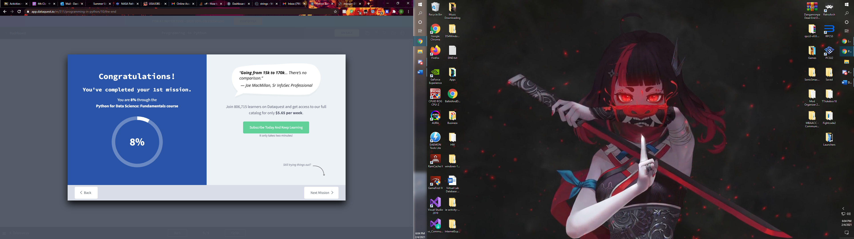

Variables and Data Types

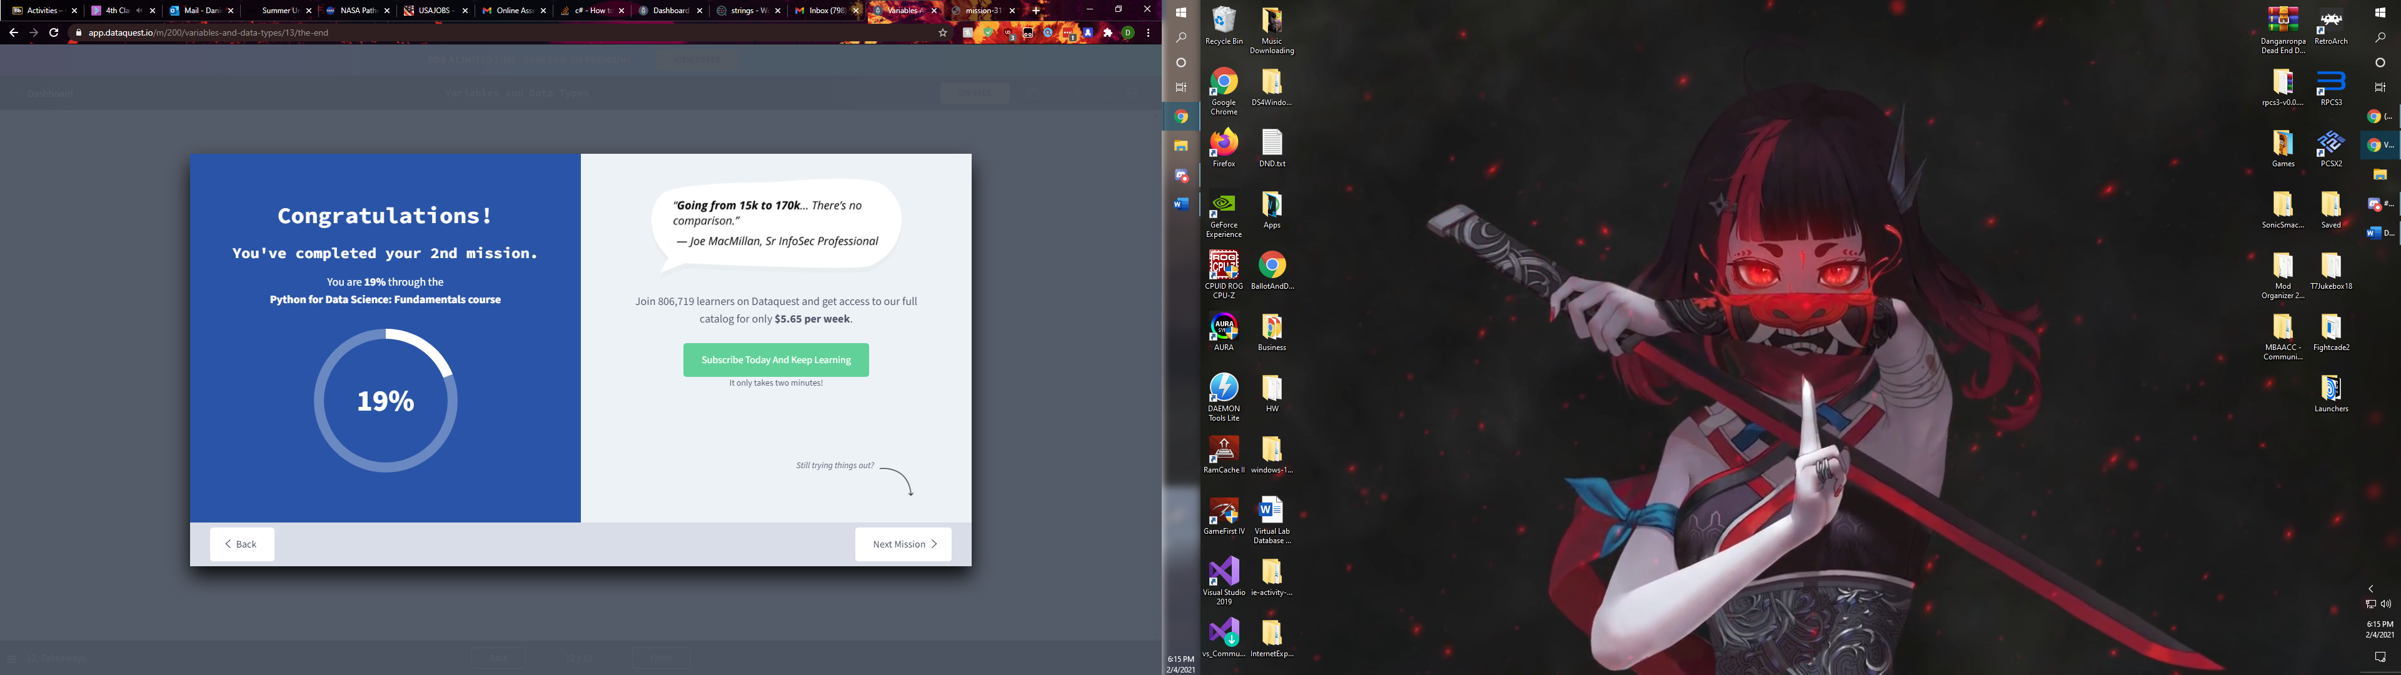

Lists and For Loops

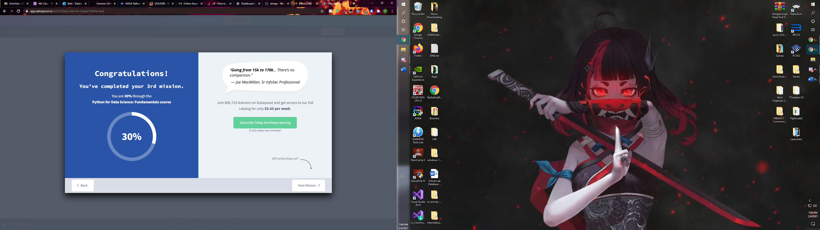

All Dataquest

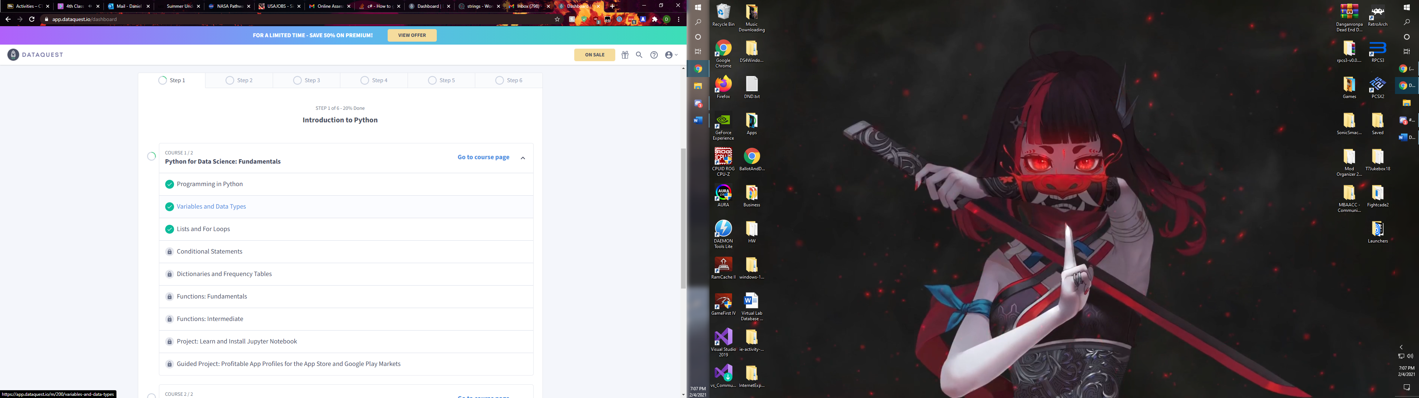

Python Conditional Statements

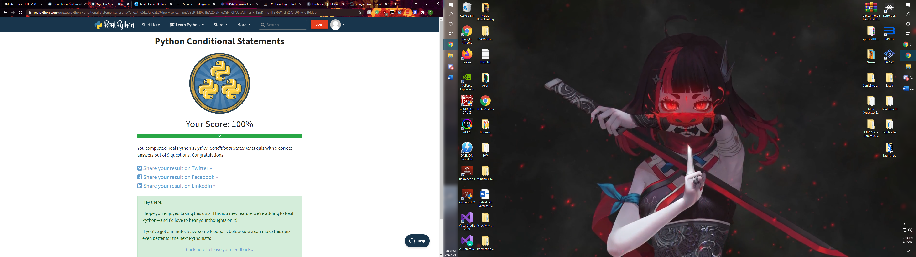

Python While Loops

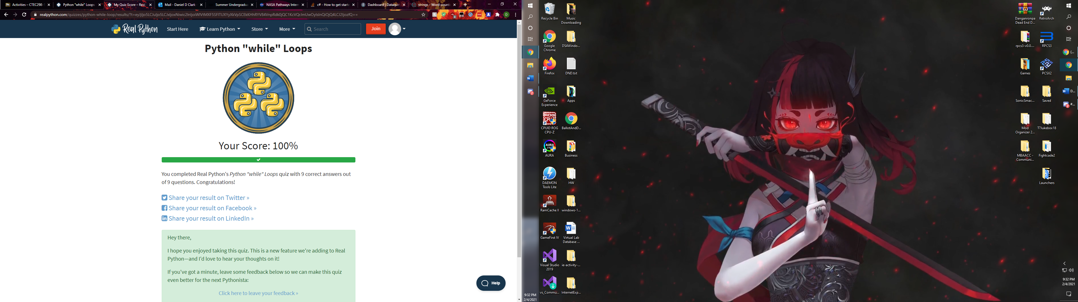

Python For Loop

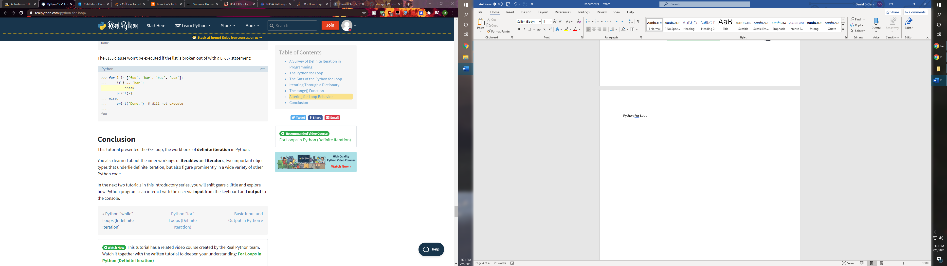

Python Dictionary/Frequency Table

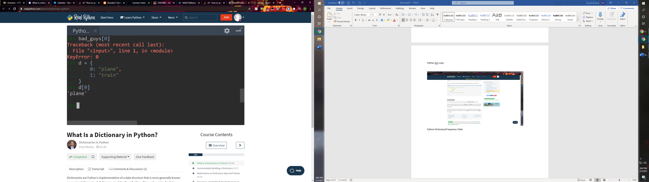

Python Functions

